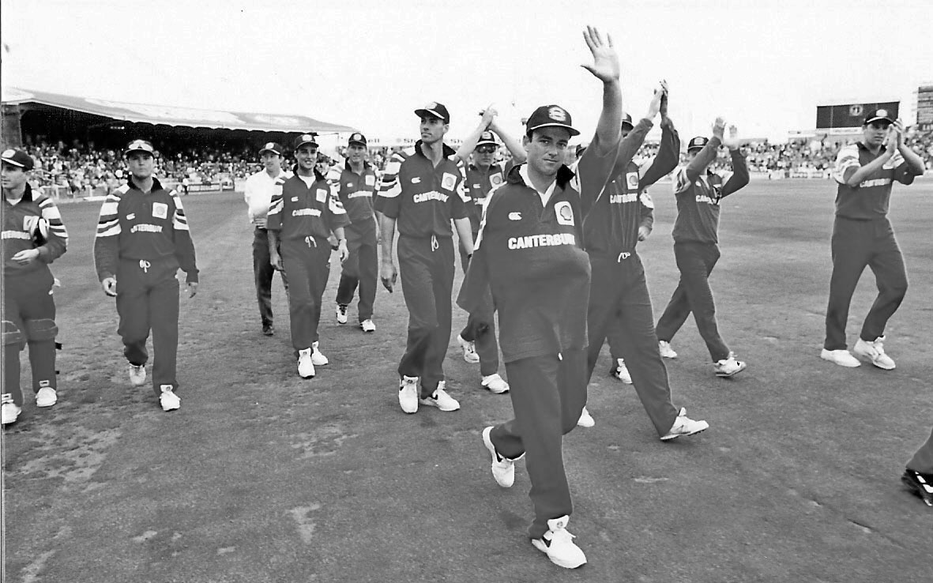

Canterbury Shell Cup team led by captain Lee Germon acknowledge the crowd after the win the Cup final.

10 January 1996 Lancaster Park

Canterbury 329/5 (NJ Astle 129. SP Fleming 109). Northern Districts 213